Roni Kaakaty

Week 1.2 Exercises

Python Bar Chart:

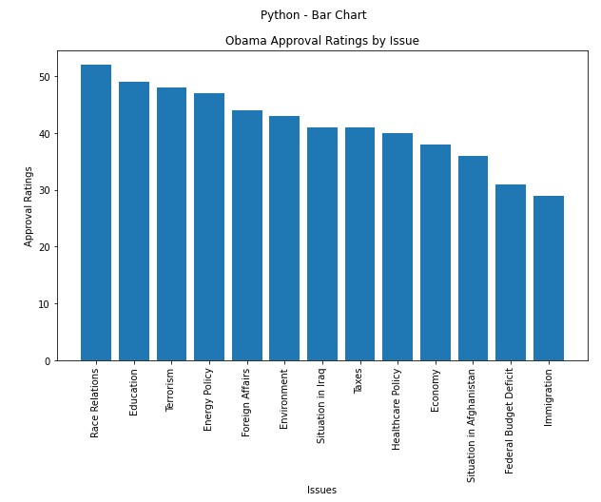

Python Stacked Bar Chart:

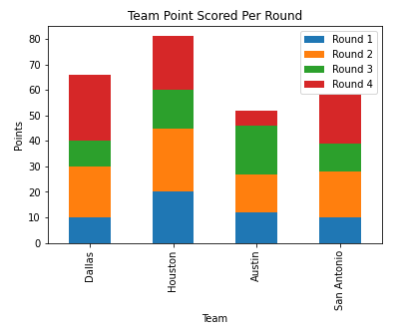

Python Pie Chart:

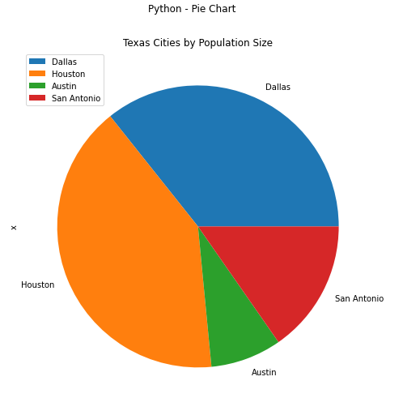

Python Donut Chart:

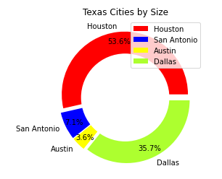

R Bar Chart:

R Stacked Bar Chart:

R Pie Chart:

R Donut Chart:

Power Bi Bar Chart:

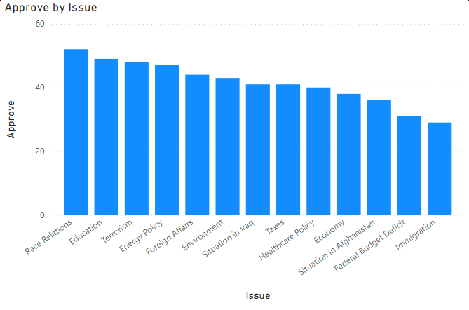

Power BI Stacked Bar Chart:

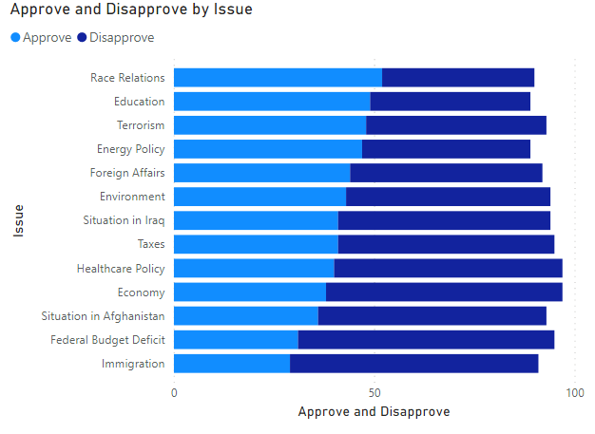

Power BI Pie Chart:

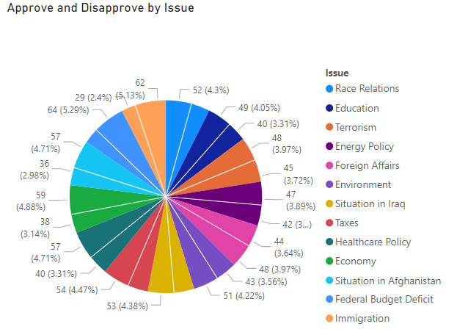

Power BI Donut Chart:

